Project Design Phase - I Solution Architecture

|  |  |
| --- | --- |
| Date | 10 October 2022 |
| Team ID | PNT2022TMID20469 |
| Project Name | Industry - Specific Intelligent Fire Management System |
| Maximum Marks | 4 Marks |

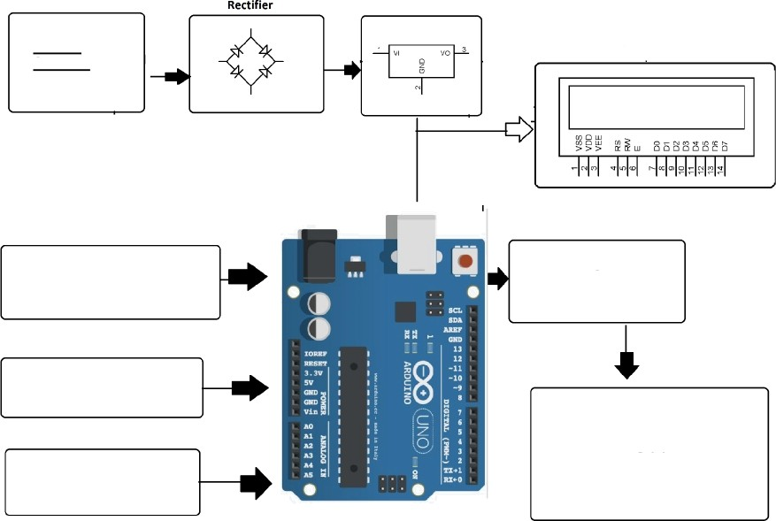

Regulator

POWR SUPPLY

Display

PIR SENSOR

WIFIMODULE

FIRESENSOR

TEMPERATURE SENSOR

IOT

ARDUINO